## 

## **Experiment-6**

**Student Name:** Gauri Prabhakar **UID:** 18BCS6201

**Branch:** 18AITAIML-2 **Section/Group:** B

**Semester:** 7 **Date of Performance:** 13th October, 2021

**Subject Name:** Advanced Database Management Lab **Subject Code:** CSP - 434

# Aim/Overview of the practical:

To Implement Pl/SQL programming using Cursors.

# Task to be done:

To Implement Pl/SQL programming using Cursors.

# Steps to be followed:

**Creating a table MARKS and then returning it:**

# CREATE TABLE MARKS(Name varchar(50), Marks int);

# INSERT INTO MARKS VALUES('Gauri',100);

# INSERT INTO MARKS VALUES('Lilly',80);

# INSERT INTO MARKS VALUES('Rose',70);

# INSERT INTO MARKS VALUES('Chelsea',50);

# INSERT INTO MARKS VALUES('Amy',90);

# SELECT * FROM MARKS;

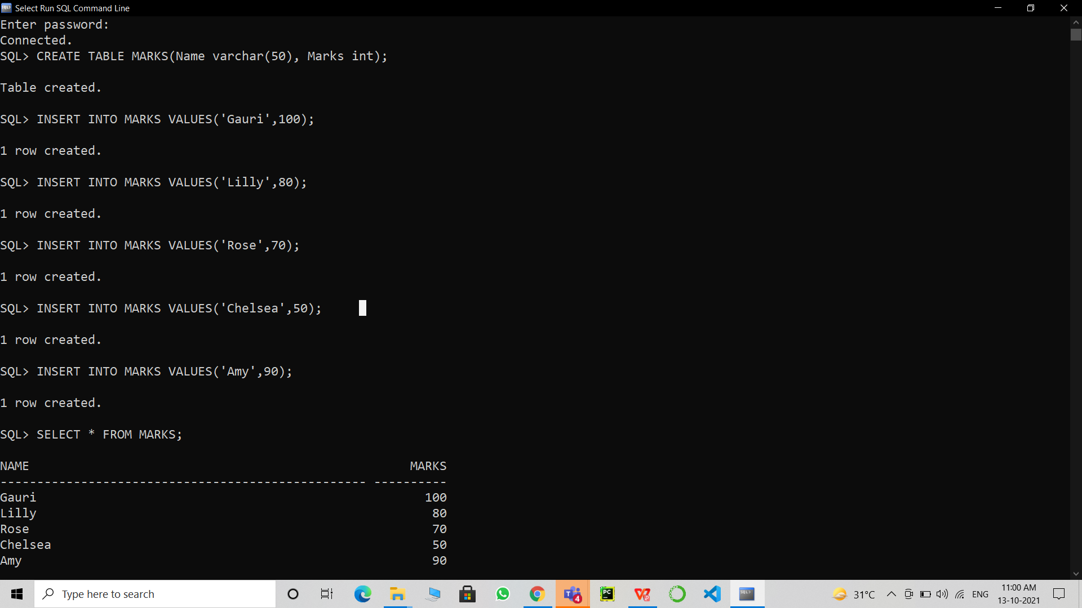

**Implementing IMPLICIT CURSORS and Updating the Marks by 1 for specific tuples which qualify a set condition and then returning the updated table:**

1. SET SERVEROUTPUT ON;

DECLARE

TOTAL_ROWS NUMBER(3);

BEGIN

UPDATE MARKS SET Marks = Marks+1 WHERE NAME LIKE 'G%';

IF SQL%FOUND THEN

TOTAL_ROWS:=SQL%ROWCOUNT;

DBMS_OUTPUT.PUT_LINE(TOTAL_ROWS || 'Students Marks Successfully Updated');

ELSIF SQL%NOTFOUND THEN

DBMS_OUTPUT.PUT_LINE('Students Marks Not Updated');

END IF;

END;

/

SELECT * FROM MARKS WHERE Name LIKE 'G%';

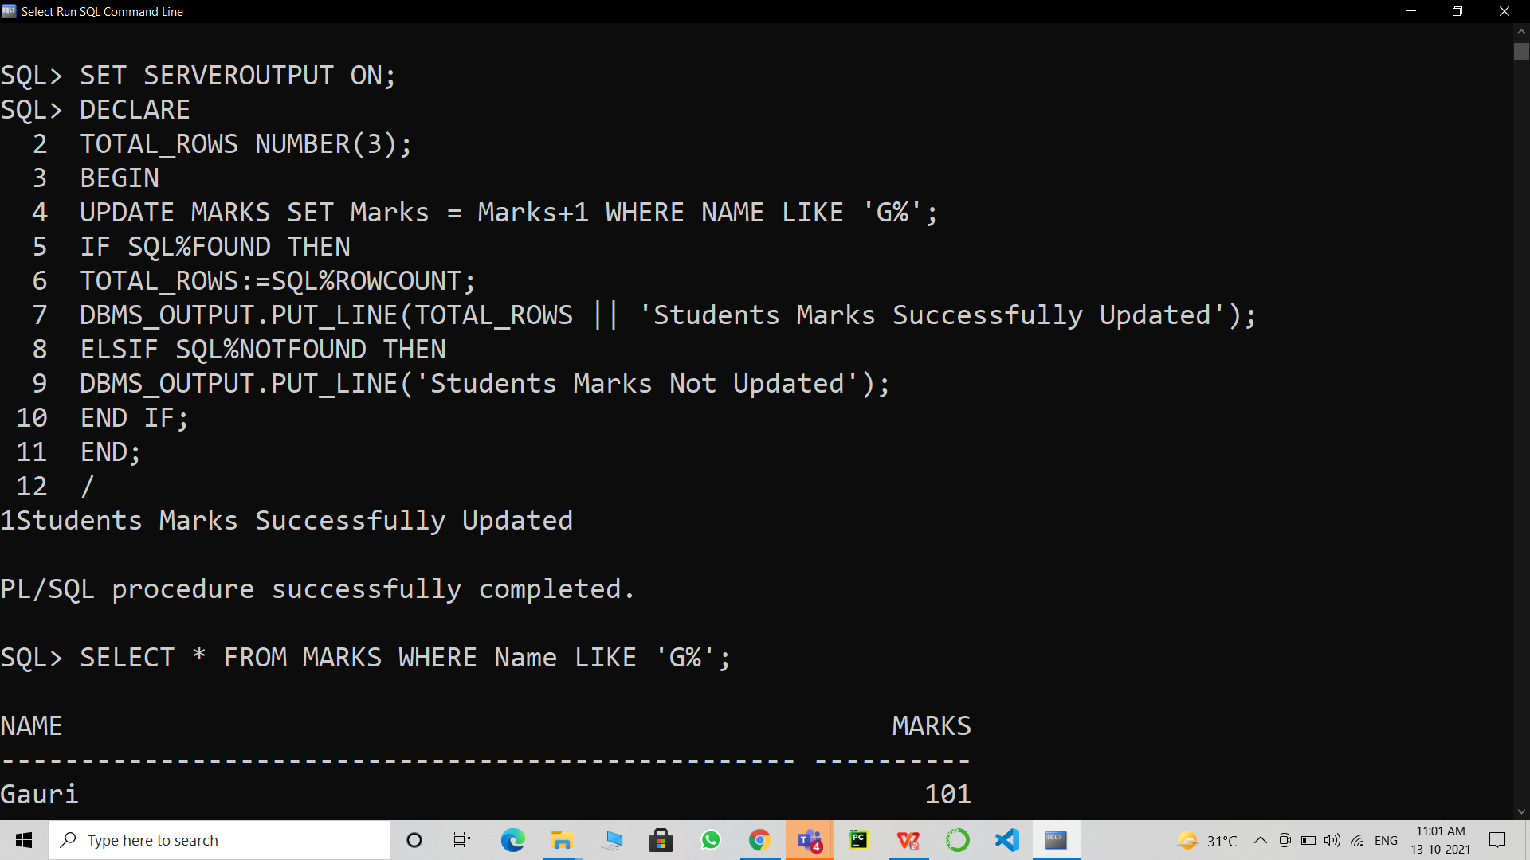

**Creating a table ‘SQUARE_AREA’ and returning it:**

1. CREATE TABLE SQUARE_AREA(Side int, Area number(10,2));

INSERT INTO SQUARE_AREA(Side) VALUES (10);

INSERT INTO SQUARE_AREA(Side) VALUES (5);

INSERT INTO SQUARE_AREA(Side) VALUES (8);

INSERT INTO SQUARE_AREA(Side) VALUES (12);

INSERT INTO SQUARE_AREA(Side) VALUES (2);

SELECT * FROM SQUARE_AREA;

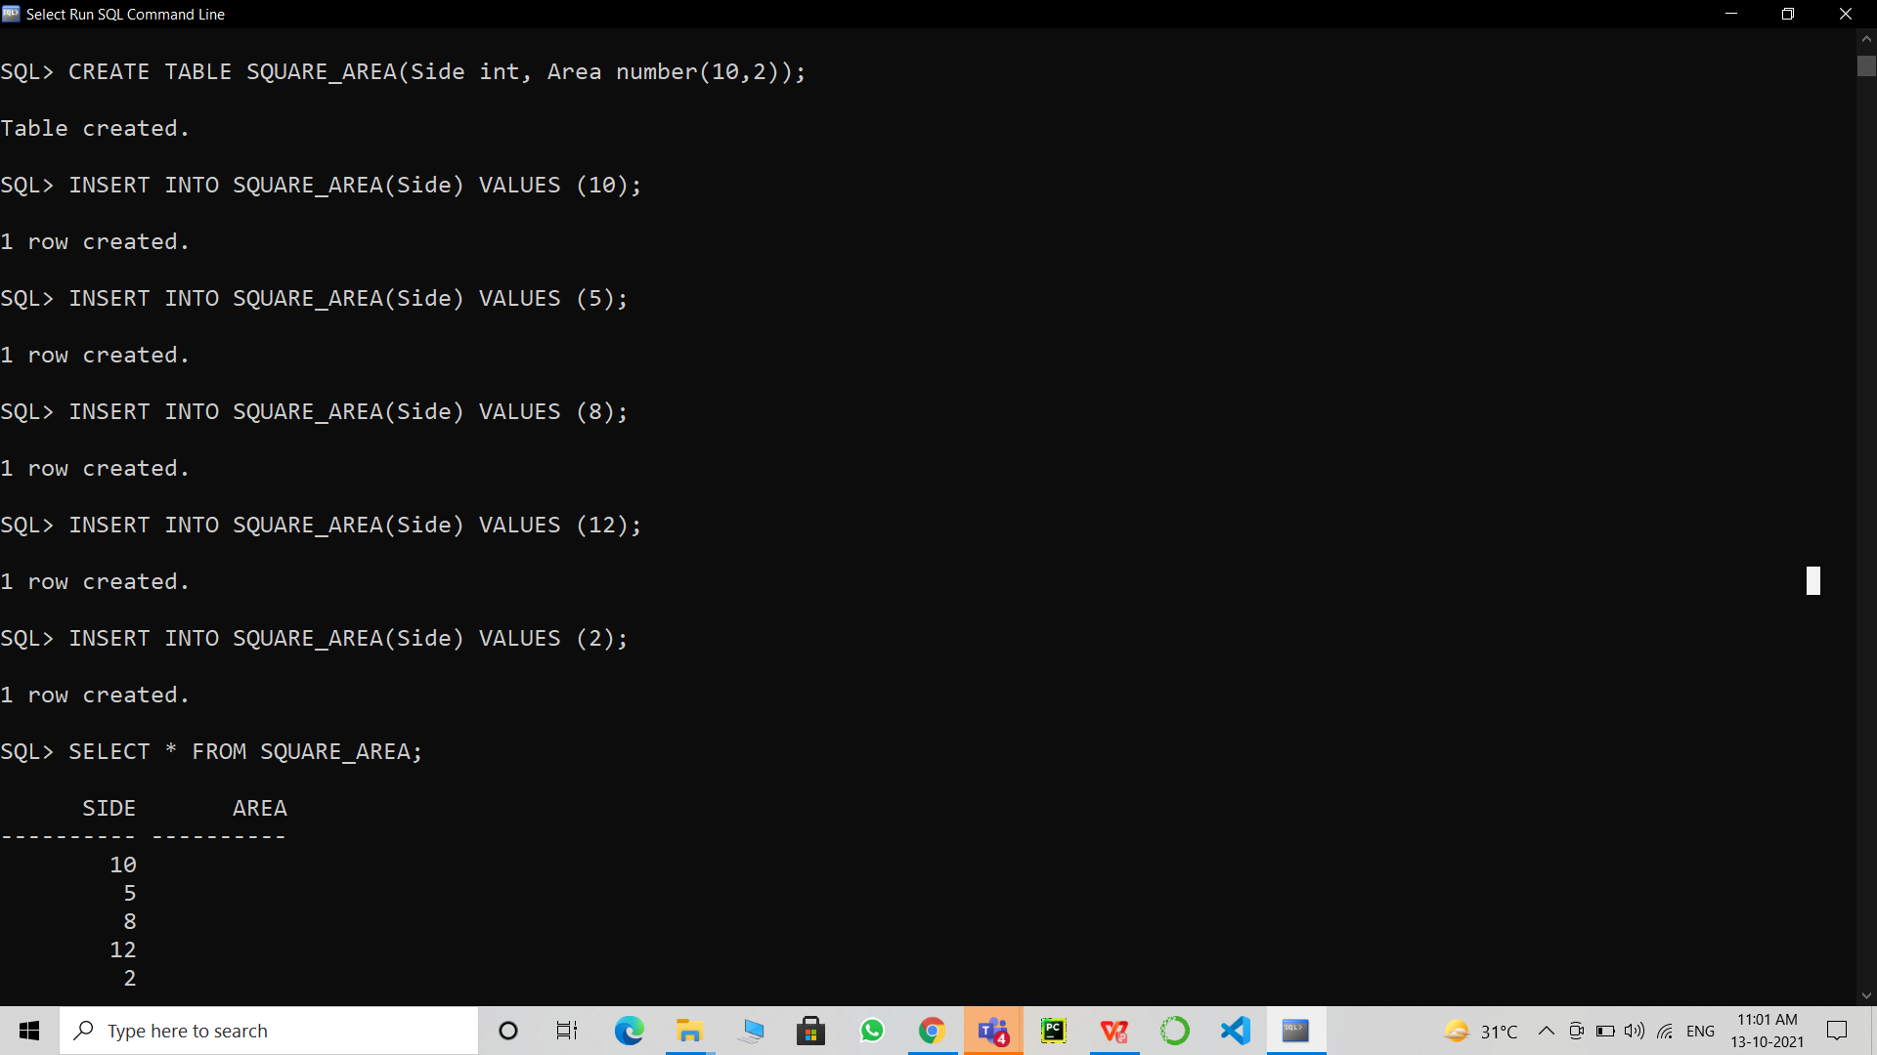

**Implementing EXPLICIT CURSOR, calculating the AREA and updating it into the ‘SQUARE_AREA’ table:**

1. DECLARE

S SQUARE_AREA.Side%TYPE;

A SQUARE_AREA.Area%TYPE;

CURSOR CALCULATED_AREA IS SELECT Side FROM SQUARE_AREA;

BEGIN

OPEN CALCULATED_AREA;

LOOP

FETCH CALCULATED_AREA INTO S;

EXIT WHEN CALCULATED_AREA%NOTFOUND;

A:=S*S;

UPDATE SQUARE_AREA SET Area = A WHERE Side = S;

END LOOP;

CLOSE CALCULATED_AREA;

END;

/

SELECT * FROM SQUARE_AREA;

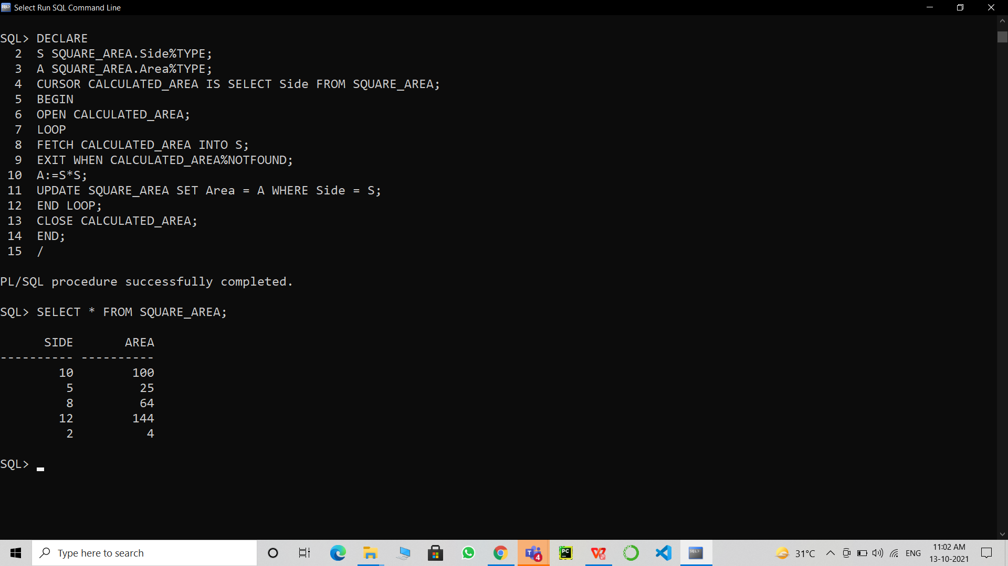

1. **Result/Output/Writing Summary:**

* Successfully implemented CURSORS.
* Successfully implemented IMPLICIT CURSORS.
* Successfully implemented EXPLICIT CURSORS.
* Successfully understood the functioning and importance of the above mentioned.

# Learning outcomes (What I have learnt):

* How to implement CURSORS on SQL Command Line.
* How to implement IMPLICIT CURSORS on SQL Command Line.
* How to implement EXPLICIT CURSORS on SQL Command Line.
* How to implement CURSORS on a table.

**Evaluation Grid (To be created as per the SOP and Assessment guidelines by the faculty):**

|  |  |  |  |
| --- | --- | --- | --- |
| Sr. No. | Parameters | Marks Obtained | Maximum Marks |
| 1. |  |  |  |
| 2. |  |  |  |
| 3. |  |  |  |